ASSIGNMENT 2

NAME: GOKUL RAJ.S

REGISTER NO: 422319205005

COLLEGE NAME: THIRUVALLUVAR COLLEGE OF ENGINEERING AND TECHNOLOGY

TEAM ID: PNT2022TMID39130

**Question:**

Build a python code, assume u get temperature and humidity values (generated with random function to a variable) and write a condition to continuously detect alarm in case of high temperature.

Code:

import random while(True):

T=random.randint(10,99) H=random.randint(10,99) if(T>30 and H<40):

print("High Temp and Values of Temperature & Humidity is:",T,H,"Alarm is ON")

elif(T<30 and H>40):

print("Low Temp and Values of Temperature & Humidity is: ",T,H,"Alarm is OFF")

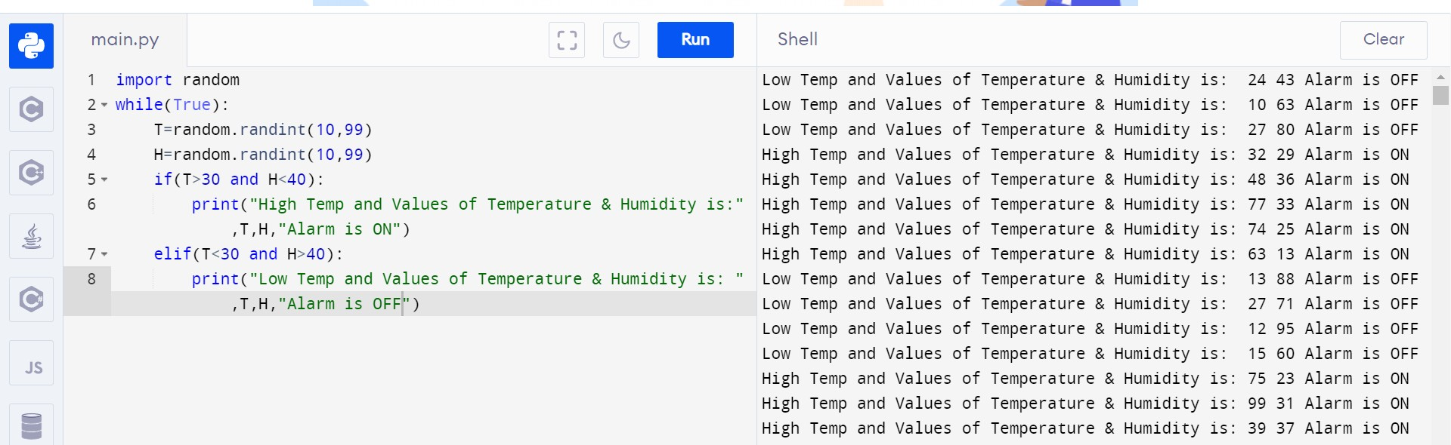Output: